**Direct work with ***** and *****.**

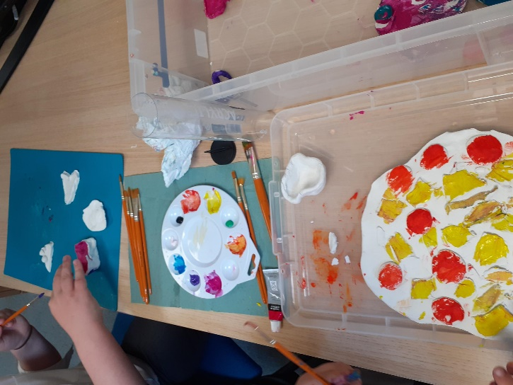

****** and ****** wanted to undertake the painting of their clay models together as they shared they enjoyed spending time toghether.

During the session ****** and ****** were observed to have a good relationship. ****** shared that they were not really enjoying school because they did not have any friends and spent most the time by themselves. ***** shared that theye felt sorry for ***** and being unhappy at school. ****** shared that they were hoping that mum was able to get ***** into a new school and they would be happier. ***** said that they would miss ***** if they moved schools however they would know they were happy and they would still get the weekends together.

***** shared that they wanted to go to another school and shared that mum was looking into this.

***** and ***** both shared that they had not heard from their father and that they did not want to see him as he had forgot about them. ****** shared that they heard father’s partner **** threatned their mother and said she would kill their mum. ****** said that they never wanted to see **** again. ***** shared simialr views and shared that at their father’s house **** said nasty things about mum and they were upset by this.

It was clear that both ***** and ***** had been in the centre of paretnal conflcits and this had further caused them emotional harm.

Following this we spoke about what they did at the weekend and they shared they went swimming and mum took them to mcdonalds afterwards. ***** shraed that they were happy at home and mum was trying not to shout so much which made them happy. ***** also shared that when ***** went into one of his moods that he tried to go to another room and wait their until mum had dealt with it which was working well.

**What’s working well:**

* ***** and ****** both engaged very well and enjoyed working with me and shared they really enjoyed the time we spend together.
* ****** and ****** shared that things at home were getting better and they were feeling safer.
* ***** and ***** shared they were enjoying working with FIP
* **What we are worried about:**
* ****** and ****** clearly have been affected emotionally around their parent’s separation and the ongoing parental conflicts that have taken place.
* ***** and ****** have a negative perspective on their relationship with their father.