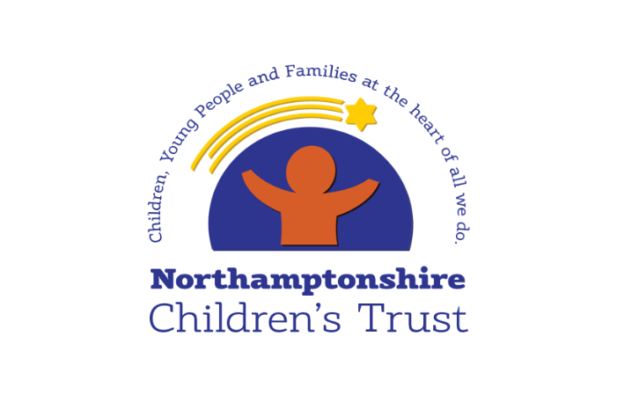
Learning from Thematic Review of Practice
6 Step Briefing
Title of CRPD - date completed
Thematic Review of children who have been subject to repeat plans

June 2021

Context / reason for review
A dip sample-style review was undertaken on cases where children have been the subject of two or more Child in Need or Child Protection Plans within the last year.

This review was undertaken to support our understanding of the reasons for children stepping up within a short period after having stepped down, so that improvement work can be clearly directed to those areas where it is needed.

What’s working well?
- In the vast majority of cases, children have an up to date assessment.
- All children who should have a plan, do have either a child in need or child protection plan on their file.
- In most cases, plans are reviewed regularly, and appropriate agencies attend the review.
- Visits to see children are, in most cases, regular and social workers have made efforts to continue to see children throughout the pandemic. In some cases, they are well recorded with an analysis of the information gathered.
- Social workers are building good professional relationships with children and their families and, in some cases, have been tenacious in gaining the trust of families.
- In the majority of cases, there is management oversight in recording and the presence of CP chairs is apparent, where appropriate.
- Closure summaries are recorded on case files when cases close, and in the majority of cases these contain a rationale for closure from the manager.
- Risk assessments related to the Covid-19 pandemic were on files to identify the children most at risk.
- Strategy discussions are usually attended by appropriate professionals. They are taking place where there are concerns that children may be suffering significant harm. Child protection enquiries are usually timely and Initial child protection conferences are, for the most part, undertaken within statutory timescales.
- Family network meetings and/or family group conferences are being held in many cases, to develop support plans for families

Worries
- Assessments and plans should be more child-focused and analytical. There is too much focus on adult behaviour rather than the impact that this is having on children. In too many cases, assessments and plans concentrate on the presenting issues without giving enough consideration to the family history and the underlying causes of the concerns.
- Threshold decisions, at all decision making points, are too often made on the assumption of harm, with some decisions being based entirely on the actions of the adults. Evidence of harm, or the likelihood of harm is not considered in enough detail, which means that there is inconsistency in the application of thresholds.
- There is too much cutting and pasting in recording with, in many cases, information repeated month after month making it hard to understand if progress is being made.
- Where children’s views are represented in meetings, conferences, and reviews these do not always relate clearly to the issues being considered.
- Danger statements and safety goals do not clearly articulate the risks and describe what life will look like for children when risks have reduced.
- The daily lived experiences of children are not always easy to understand from recording and where there is more than one child in a family it is difficult to discern the individual and unique characteristics of each child.
- Professionals too often take what parents are saying at face value and do not show enough professional curiosity about what they are being told, leading to over optimism about parents’ capacity to make and sustain change.
- Some families have not received the services they needed due to the Covid-19 pandemic and this has caused delay which is not always taken into account when cases are closed.
- Cases are often closed before changes are embedded and without a thorough analysis of what has changed, how changes will be maintained, and what the early warning signs of a dip would be.
- Where children are experiencing long term, chronic neglect, the impact of this is not recognised quickly enough

What needs to happen? Agreed actions
- Close focus is now required to implement Safety Planning for every child which places the family at the centre of creating a plan that can work in the longer term
- When safety plans are drawn up, families should lead this process. The plan should describe exactly how families are going to ensure that children are kept safe whilst there are services involved with them.
- We need to build families understanding and responsibility, identify where the strength and safety is, so families and their safety network can satisfy services that children can remain living safely within their family and professionals can withdraw
- We need to work hard to help families to sustain change in the longer term and good Safety Planning will support improvement here
- Professionals should be guided away from referring to parents or young people as ‘non-engaging’ and steered towards an approach that encourages the professional group to see themselves as ‘struggling to secure meaningful engagement’.
- Threshold decisions should be clearly based on an analysis of harm. The analysis should include an exploration of what the harm is, what is the significance of the harm, how likely the harm is to occur, how imminently it is likely to occur and what the impact is/would be.
- Direct work should be clearly linked to outcomes identified in planning
- In supervision, managers should challenge social workers about any narratives that have developed, about perceived changes, sustainability, motivation of parents to maintain change etc. so that cases are not closed with an over optimistic view of parents’ capability to maintain positive changes.

Good practice
- We have a solid foundation to build upon; QA activity consistently shows our practitioners are able to build good relationships with families and it is these relationships which are the key to success.

