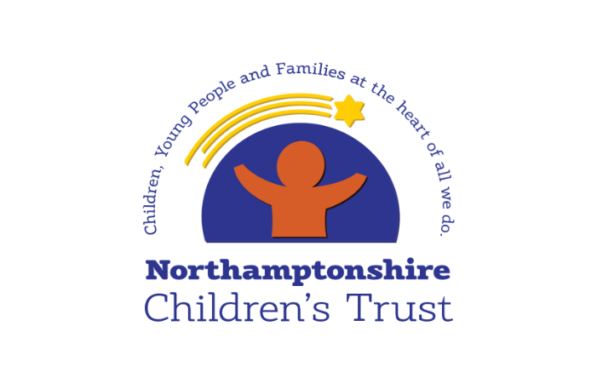
Learning from Thematic and Peer Collaborative Reflective Practice Discussions
6 Step Briefing
Title of CRPD - date completed
Peer CRPD
&
Thematic CRPD - Are children supported to remain living safely within their family?

May 2021

Context / reason for CRPD
Peer CRPD - side by side time spent with workers reflecting on the quality of our practice and how we are making a difference for children; identifying learning and celebrating good practice

Thematic CPRD – alongside the review of the child’s experience, some additional questions were asked to help us understand our progress against recommendations made during Support and Safeguarding Practice Week (December 2020)

What’s working well?
- CRPD findings consistently show that Social Workers develop good relationships with children and families – they know the children they are supporting well and are able to effectively engage parents
- All children have a plan of support in place and assessments are carried out with sensitivity and understanding
- Children are seen regularly by their Social Worker – this helps children build a relationship with their Social Worker
- Of the records reviewed, around a third had a Safety Plan in place with one of them being noted as a good example
- Where Safety Plans are in place there is evidence that they were built alongside the family; this is positive as this approach is integral to our model of practice
- Direct work with children was evident on a third of children’s records; there is gradual improvement seen here. Although it was not always easy to see how this work directly impacted on the direction of the child’s plan, 2 records demonstrated this well and it was clear how the child’s voice has influenced our work
- For the children with a Safety Plan, we could clearly see who is in their safety network; this offers reassurance that these children are living with people around them who are able to support and protect
- Although not all children, for some the trajectory of the plan was clear; there is some gradual improvement seen here, this means that these children and their families are clear about what needs to happen for safety to be achieved. For these children it will be clear when they longer need the support of their Social Worker

Worries
- CRPD feedback shows we need to further embed Signs of Safety; we need real focus now on ensuring every child has a high quality Safety Plan
- No children’s versions of the Safety Plan were in place (Explanation for the Child).
- Too many children do not have an up to date chronology on their record
- Too many children do not have an up to date genogram on their record
- There is still some work to be done to ensure consistency of quality of Safety Plans, so we fully capture the impact for the child and can clearly see how the Safety Plan is helping keep the child safe
- None of the children whose records were reviewed had been discussed during a Family Network Meeting
- Too many children had no explicit Bottom Lines on their record

What needs to happen? Agreed actions
- As work continues across all service areas to support implementation of Signs of Safety we will see an increase in the application of the model in practice. Close focus is now required to implement Safety Planning for every child which places the family at the centre of creating a plan that can work in the longer term

- We need to build families understanding and responsibility, identify where the strength and safety is, so families and their safety network can satisfy services that children can remain living safely within their family and professionals can withdraw

- We need to work hard to help families to sustain change in the longer term and good Safety Planning will support improvement here. We have a solid foundation to build upon; QA activity consistently shows our practitioners are able to build good relationships with families and it is these relationships which are the key to success

Good practice
- We have a solid foundation to build upon; QA activity consistently shows our practitioners are able to build good relationships with families and it is these relationships which are the key to success.

