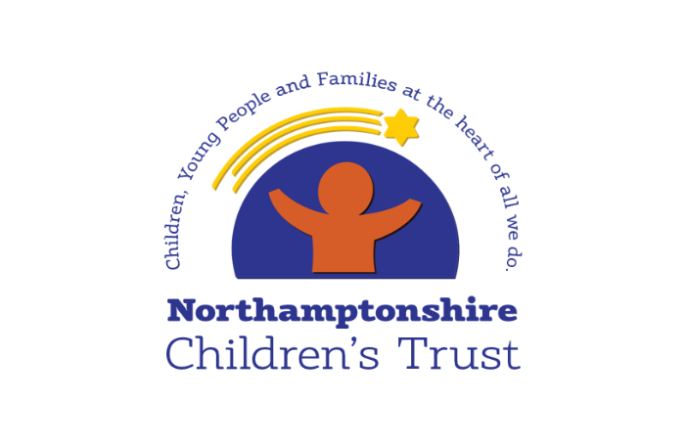
Learning from Thematic and Peer Collaborative Reflective Practice Discussions
6 Step Briefing
Title of CRPD - date completed
Peer CRPD
&
Thematic CRPD - Engaging and working with fathers in a meaningful way

April 2021

Context / reason for CRPD
Peer CRPD - side by side time spent with workers reflecting on the quality of our practice and how we are making a difference for children; identifying learning and celebrating good practice

Thematic CPRD – alongside the review of the child’s experience, some additional questions were asked to help us fully understand our position, in light of our own findings during the previous two quarters, and the national picture related to lack of meaningful contact with fathers

What’s working well?
- It is evident that Social Workers develop good relationships with children and families – they know the children they are supporting well
- Social Workers and Team Managers have a good understanding of children’s circumstances and needs
- There is evidence of good work with partners which helps develop a network of support around children
- Children are seen regularly by their Social Worker – this helps children build a relationship with their Social Worker
- Although an area for improvement, three children’s records saw good use of Signs of Safety
- Good Management Oversight was seen on children records; it is improved in the last quarter as records reviewed show increase in those meeting good (30% to 70%) since February 2021. Team and Service Manager focus supported by Brilliant Basics and management development training have had a positive impact here
- There is evidence of proactive work to engage with fathers; there is still work to be done but this shows us as an organisation taking responsibility for this engagement
- Meaningful input from fathers is seen on children’s records; in most cases, where we are working with families who have more than one father, each father is spoken with individually

Worries
- Audit feedback would suggest we need to further embed Signs of Safety, with ongoing focus on the basics of Danger Statements, Safety Goals, Safety Planning and trajectories – this is known and the implementation is progressing well
- Safety Plans have been a recent focus of improvement activity – this should be a continued focus as 4 of the 12 Peer CRPDs found the child had no Safety Plan
- Too often supervision of children’s records is not timely, lacks reflection, and does not have SMART actions - work to streamline processes around supervision have recently been implemented and this will support managers to provide a well-crafted record – it is too early to measure impact/improvement here
- Too many children do not have an up to date chronology on their record
- Too many children do not have an up to date genogram on their record
- Some children’s plans were not progressed in a timely manner due to multiple changes of Social Worker

What needs to happen? Agreed actions
- Audit feedback would suggest we need to further embed Signs of Safety, with ongoing focus on the basics of Danger Statements, Safety Goals, Safety Planning and trajectories – this is known and the implementation is progressing well
- Safety Plans have been a recent focus of improvement activity – this should be a continued focus as 4 of the 12 Peer CRPDs found the child had no Safety Plan
- Too often supervision of children’s records is not timely, lacks reflection, and does not have SMART actions - work to streamline processes around supervision have recently been implemented and this will support managers to provide a well-crafted record – it is too early to measure impact/improvement here
- Too many children do not have an up to date chronology on their record
- Too many children do not have an up to date genogram on their record
- Some children’s plans were not progressed in a timely manner due to multiple changes of Social Worker

Good practice
In the records looked at during this CRPD, most children’s fathers were supported to contribute in a way that has influenced planning; this demonstrates we are not looking at fathers only as either a risk or a resource. This means children see that their mothers are not held solely responsible, and children are provided with a full assessment which their father is an active participant in.

In the records looked at during this CRPD, where there was more than one father in a family, we saw that Social Workers made sure all of the fathers view were sought. The children in these families can be reassured that their fathers are involved in care planning.

