Clutter Image Rating: Kitchen
Please select the photo that most accurately reflects the amount of clutter in your room.

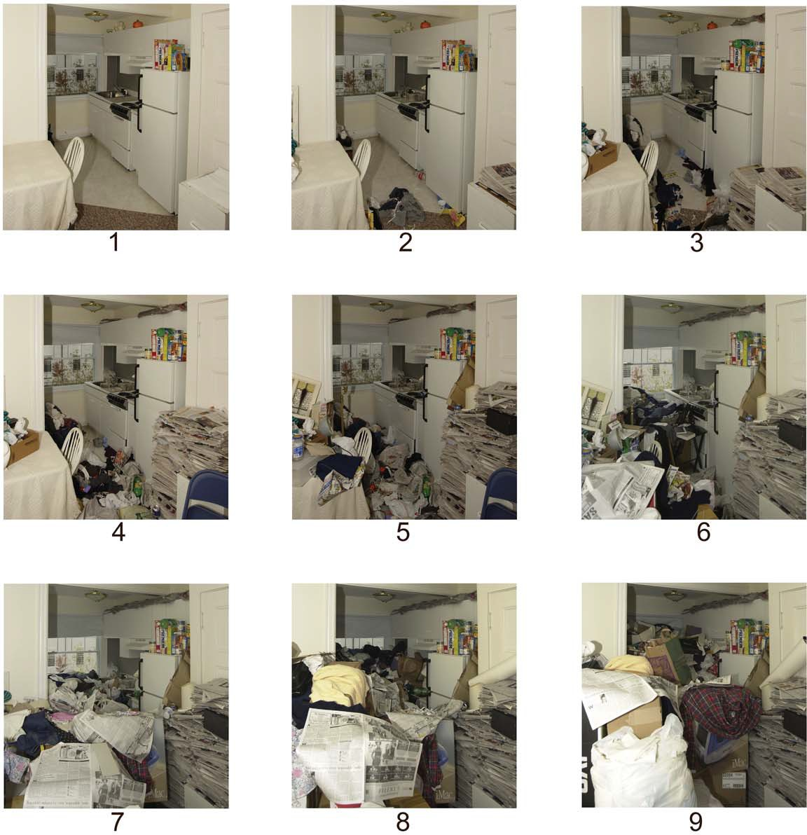

Clutter Image Rating: Bedroom
Please select the photo that most accurately reflects the amount of clutter in your room

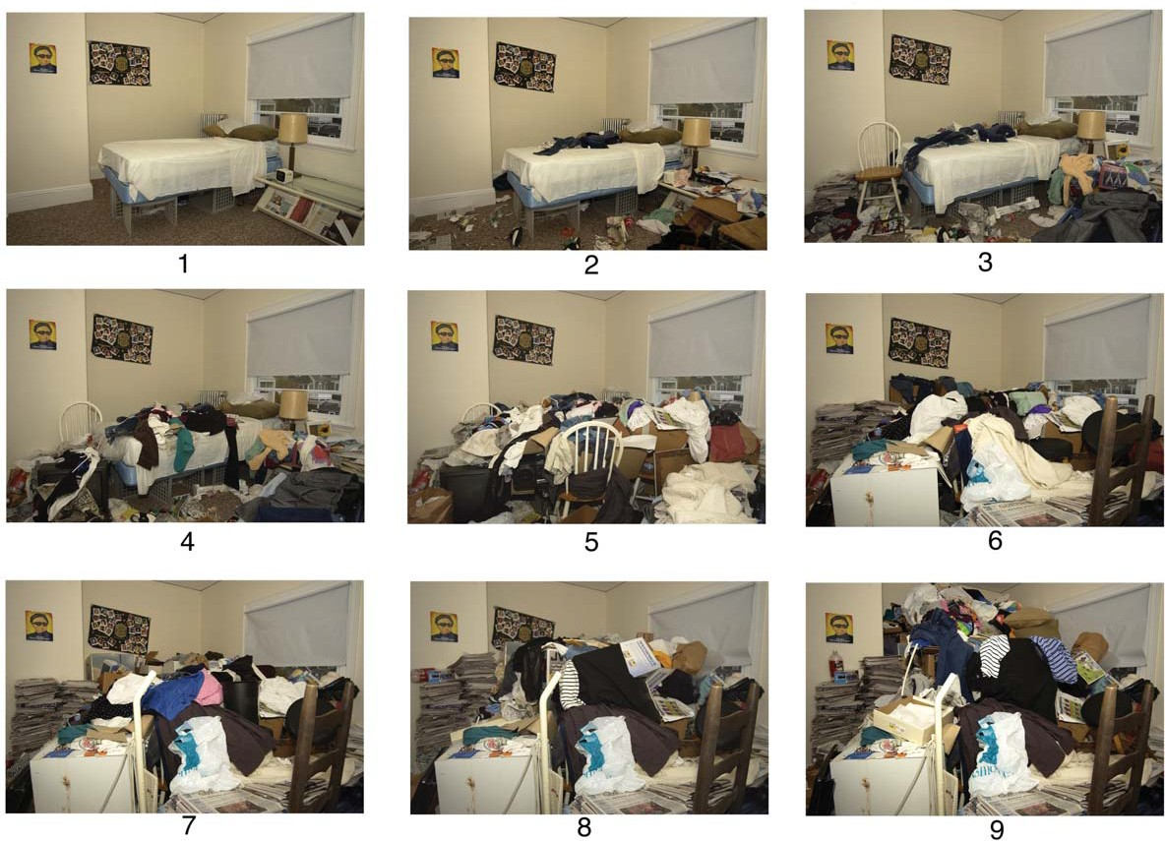

Clutter Image Rating: Living Room
Please select the photo that most accurately reflects the amount of clutter in your room

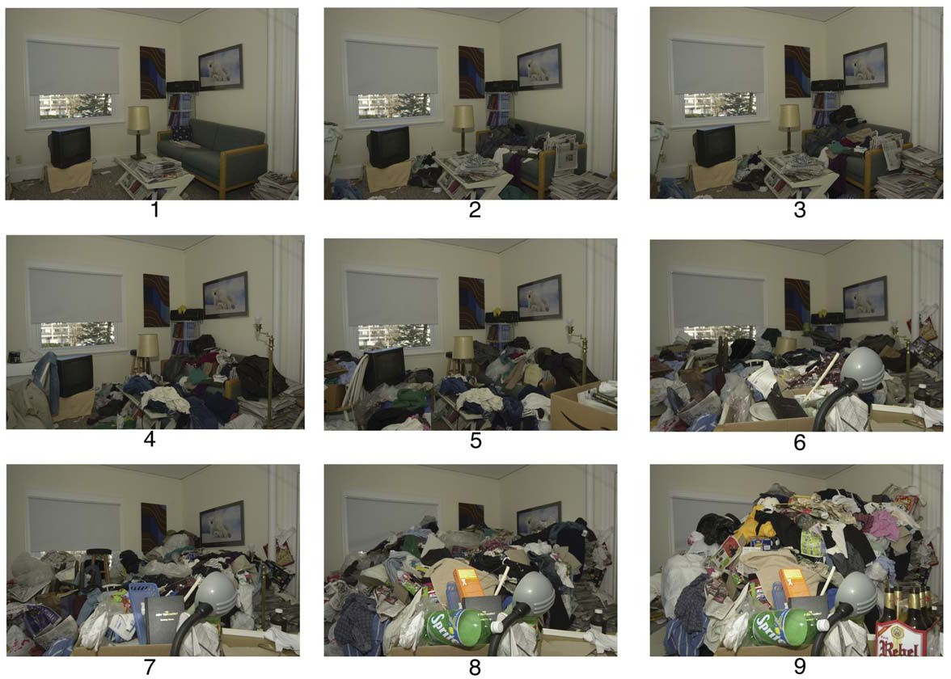

Clutter Image Rating

Using the 3 series of pictures (CIR: Living Room, CIR: Kitchen, and CIR: Bedroom),
please select the picture that best represents the amount of clutter for each of the rooms of your home. Put the number on the line below.

Please pick the picture that is closest to being accurate, even if it is not exactly right.
If your home does not have one of the rooms listed, just put NA for “not applicable” on that line.

Room Number of closest corresponding picture (1-9)

Living Room
Kitchen
Bedroom #1
Bedroom #2

Also, please rate other rooms in your house that are affected by clutter on the lines below. Use the CIR: Living Room pictures to make these ratings.

Dining room
Hallway
Garage
Basement
Attic
Car
Other Please specify:

Please specify:

Personal Session Form

Initials:
Session No:
Date:

Agenda: Think about how photos 4-9 become a fire risk (flammables and obstacles blocking exit routes)
Think about how photos 4-9 impact on ventilation
Think about how photos 4-9 impact on environmental health and safe living space
Think about how photos 4-9 might impact emotional health
Think about how photos 4-9 might impact on your children
What needs to change? Who in your support network can support you with this?

Main Points:

Homework:

To Discuss Next Time:

