Section one:

Background information
1a: Introduction and toolkit summary
1b: What we know about neglect
In order to assess a parent’s capacity to meet their child’s needs, it is important in cases where neglect is suspected to examine and gain an understanding of both the current circumstance and the parents own early experience. This should form the basis for any assessment undertaken.
This toolkit is for practitioners to use with parents/carers. Section 1a provides guidance for how to use the assessment tool.
We would like to acknowledge that the Action for Children toolkit has been adapted from the work of Dr O P Srivastava, Consultant Community Paediatrician, and Luton Child Development Centre who developed the original Graded Care Profile.

This toolkit consists of guidance, assessment tools and recording documents to support practitioners to:
- Identify early, children whose developmental needs are being insufficiently met placing them at risk of achieving poor educational, emotional and social outcomes
- Focus on the main areas of concern – when things can seem overwhelming and chaotic
- Engage parents in looking at their parenting using pictures and descriptions that help discussion and provide an opportunity for working together and agree required actions
- Feel more confident in making judgments and decisions that they can share with other agencies
- Deliver better outcomes for vulnerable children and their families
- Develop an improved service response that can be rolled out across the setting
- Improve co-working relationships between social work services, health, education and other agencies

Neglect is the most prevalent form of child maltreatment in the UK. We know that intervening in neglect is likely to be costly, requiring intensive, long-term, multi-faceted work by a highly skilled workforce.
Neglect can have a devastating impact on all aspects of child development, and this impact can last throughout their life. It differs from other forms of abuse because it is frequently passive, it is more likely to be a chronic condition than crisis led and often overlaps with other forms of maltreatment. There is a repeated need for intervention with families requiring long term support. The indicators are often missed with no early intervention and a lack of clarity between professionals on the agreed intervention threshold.

Definition
Our Safeguarding Framework in Action for Children defines neglect as the persistent failure to meet a child’s basic physical and/or psychological needs, likely to result in a serious impairment of the child’s health or development.
Neglect may occur during pregnancy as a result of maternal substance abuse. Once a child is born, neglect may involve a parent or carer failing to:
- provide adequate food, clothing and shelter (including exclusion from home or abandonment);
- protect a child from physical and emotional harm or danger
- ensure adequate supervision (including the use of adequate care-givers); or
- ensure access to appropriate medical care or treatment

The following definition is also helpful:
1. 10% of children are neglected or psychologically abused: Ruth Gilbert, Cathy Spatz Widom, Kevin Browne, David Fergusson, Elspeth Webb, Staffan Janson (The Lancet, Child Maltreatment Series, articles 1-3, published December 2008 and January 2009)
“neglect occurs when the basic needs of children are not met, regardless of cause”
Managing neglect is complex and multi-faceted and cannot be easily defined. Neglect differs from other forms of abuse because it is:
- frequently passive
- the intent to harm is not always present
- it is more likely to be a chronic condition rather than crisis led and therefore impacts on how we respond as agencies
- overlaps often with other forms of maltreatment
- is often a revolving door syndrome where families require long term support
- lacks clarification between professionals on the agreed threshold for intervention.
Therefore the way in which we define neglect can determine how we respond to it.

2. Factors which contribute to neglect
- Family violence, modelling of inappropriate behaviour
- Multiple co-habitation and change of partner
- Alcohol and substance abuse
- Maternal low self-esteem and self-confidence
- Poor parental level of education and cognitive ability
- Parental personality characteristics inhibiting good parenting
- Social and emotional immaturity
- Poor experience of caring behaviour in parents own childhood
- Depriving physical and emotional environment in parents own childhood
- Experience of physical, sexual, emotional abuse in parents own childhood
- Health problems during pregnancy
- Pre-term or low birth weight baby
- Low family income
- Low employment status
- Single parenting
- Teenage pregnancy

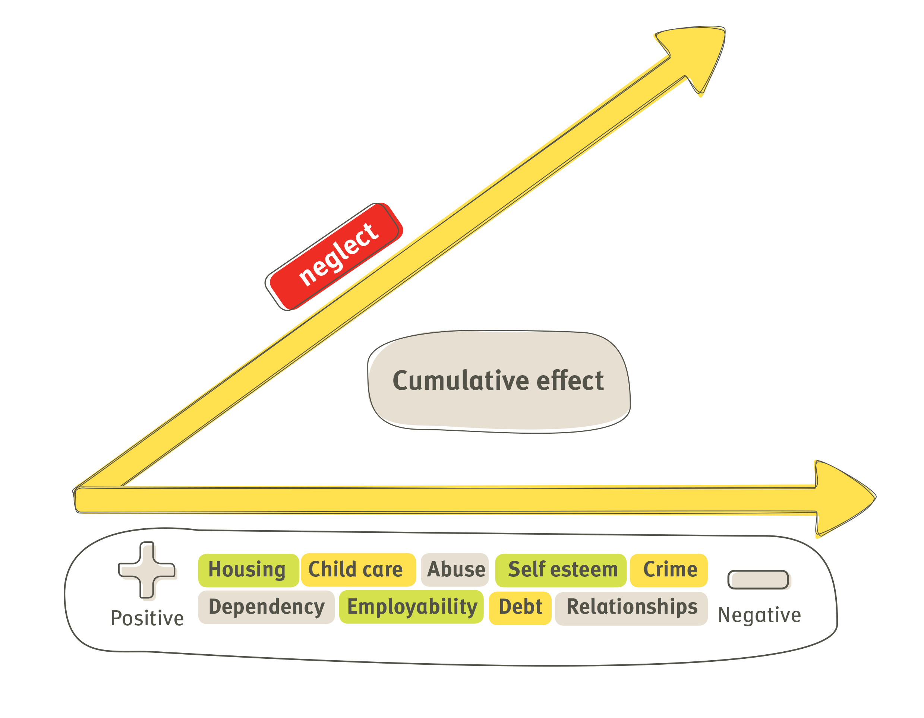

3. Management
Effective interventions to achieve the best outcome for the child must be based upon clear assessment processes. Neglectful parental behaviour is least understood, but a growing body of research suggests that defining the causation of neglect in individual families can help to determine the most effective management response. Each intervention must be targeted and tailored to meet the individual and unique needs of every family.
Research3 suggests neglect can be described in three ways. The following guidance may help to facilitate the planning and management of neglect cases to provide the most effective professional response.
- disorganised neglect
- emotional neglect
- depressed neglect

i. Disorganised neglect
Description:
- families have multi-problems and are crisis-ridden
- care is unpredictable and inconsistent, there is a lack of planning, needs have to be immediately met
- mother/parent appears to need/want help and professionals are welcomed, but efforts by professionals are often sabotaged.
Consequence or Impact:
- children became overly demanding to gain attention
- families constantly recreate crisis, because feelings dominate behaviour
- parents feel threatened by attempts to put structures and boundaries into family life
- interpersonal relationships are based on the use of coercive strategies to meet need.
Case Management:
- these families respond least to attempts by professionals to create order and safety in the family
- feelings must be attended to develop trust, express empathy and reassurance, be predictable and provide structure in the relationship
- mirror the feelings
- gradually introduce alternative strategies to build coping skills
- support will be long term.

ii. Emotional neglect
Description:
- opposite of disorganised families, where focus is on predictable outcomes
- family may be materially advantaged and physical needs may be met but no emotional connection made
- children have more rules to respond to and know their role within the family
- parental responses lack empathy and are not psychologically available to the child
- parental approval/attention achieved through performance.
Consequence/Impact:
- children learn to block expression/or awareness of feelings
- they often do well at school and can appear overly resilient, competent/mature
- they take on the role of care giver to the parent which permits some closeness that is safer for the parent
- children may appear falsely bright, self-reliant, but have poor social relationships due to isolation
- the parent may have inappropriate expectations, in relation to the child’s age/development.

Management:
- as families appear superficially successful there is likely to be less professional involvement
- parents will feel particularly threatened by any proposed intervention. The impact of separating the child from an emotionally neglectful parent can be particularly devastating for the child when they have taken on a parental role
- parents need to learn how to express feelings - practice smiling, laughing, soothing, to emotionally engage with the child
- children will benefit from opportunities that are socially inclusive and open them up to other emotionally positive experiences
- help parents to access other sources of support/activities to reduce the impact of their withdrawn state
- goal - to move families towards the less withdrawn version of emotional neglect

iii. Depressed neglect
Description:
- parents love their children but do not perceive their needs or believe anything will change
- parent is passive and helpless
- uninterested in professional support and is unmotivated to make change
- parental presentation is generally dull/withdrawn.
Consequences/Impact:
- parents have closed down to awareness and understanding of children’s needs
- parents may go through the basic functions of caring - feeding, changing, but there is a lack of response to child’s signals
- child is likely to either give up when persistently given no response and become withdrawn/sullen or behaviour may become extreme.
3 Child Neglect: Causes and Contributors by P McKinsey Crittenden in H Dubowitz, Neglected Children: Research, Practice and Policy - Sage Publications 1999, p47 - 68.

Management:
- children benefit from access to stimulation, responsive alternative environments eg. day care
- parents are unlikely to respond to strategies which use a threatening/punitive approach that requires parents to learn new skills
- medication may be helpful but beware side effects
- emphasise strengths
- parental education needs to be incremental and skills practised and reinforced over time to overcome parents belief that change is not possible
- support will most likely need to be long term and supportive in nature.
Whilst categorisation can aid planning and management it can also be deceptive as situations vary and will require tailored support.

4. Roles and responsibilities
All agencies whether in the statutory or voluntary sector have a duty:
- to share information about children who are suspected to be at risk of harm from neglect
- to make a contribution to the assessment process and where appropriate
- to take the lead responsibility for co-ordinating the assessment and multi-agency meetings
The assessment tool will provide a benchmark for determining what change, if any, occurs over time. It will assist in clarifying when conversations should take place between partner agencies and when additional services are required, including social care services. It enables parents to recognise the needs of their child and supports practitioner to keep the focus on the child.

