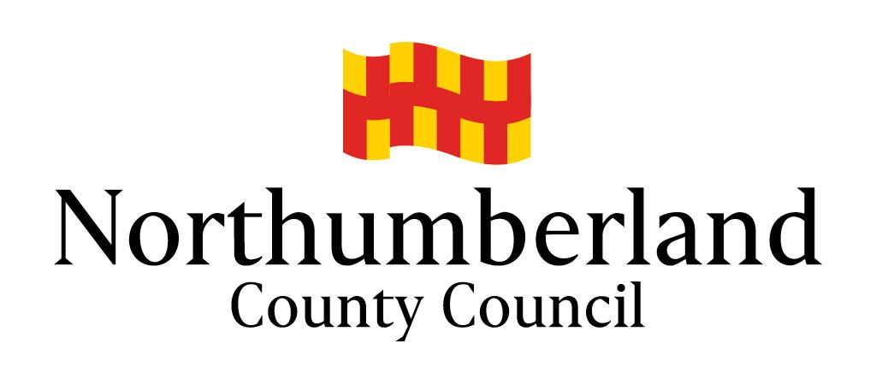
Northumberland County Council
Children’s Services Directorate

AMENDED / PLO Plan
In respect of

Date of Plan -

PARTIES TO AGREEMENT (names and titles)

DANGER STATEMENT / WHAT WE ARE WORRIED ABOUT / REASON FOR SAFETY PLAN

CURRENT CARE ARRANGEMENTS

PLO PLAN

What needs to happen | By Who | By When

PARENTS’ VIEWS

CHILD/REN VIEWS - if applicable

SIGNATURES

Name
On behalf of the Local Authority:
Dated:

Name
Parent:
Dated:

Name
Parent:
Dated:

