Direct Payments Workflow-Guide for Social Workers and Managers

This should be completed for all new direct payments requests and for all children who currently have a direct payment but haven't had their direct payment reviewed at panel. For those existing direct payments requiring a first review Sandra Blackwood will contact you with a date and time of the panel to attend-you should complete this workflow process following the child’s CIN review and before attending the panel. Once you have discussed the child at panel the first time, if continuation of the direct payment is agreed the next review date will be set.
If you are submitting a new direct payment request you should refer to the timetable as to when the last submission will be considered for each panel.
From the child’s demographics screen on the right-hand side under Events is the link to Start Direct Payments
The Social Worker selects the link and will need to add the Start Date for the process and click start
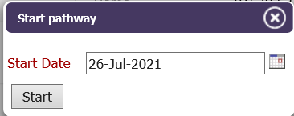
If relationships, you will see this screen
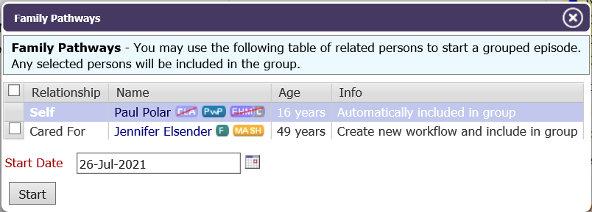
The social worker clicks to start the form, assigns the form to themselves (by selecting the radio button and clicking assign)
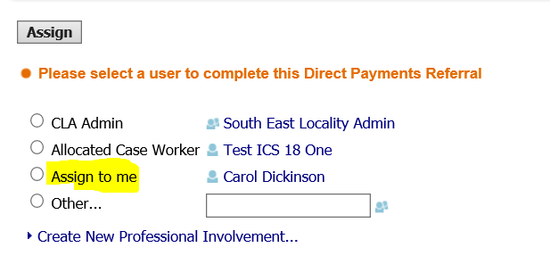
They then click to Start the Direct Payments Referral form and start blank – worker fills in the Brief Background details section and finalises the enquiry
The worker should ensure that they follow the guidance notes within the form so that it is clear what the purpose of the direct payment is and the outcome looking to be achieved for the child.
The task then goes to the manager who will select to update the direct payments enquiry adding their agreement
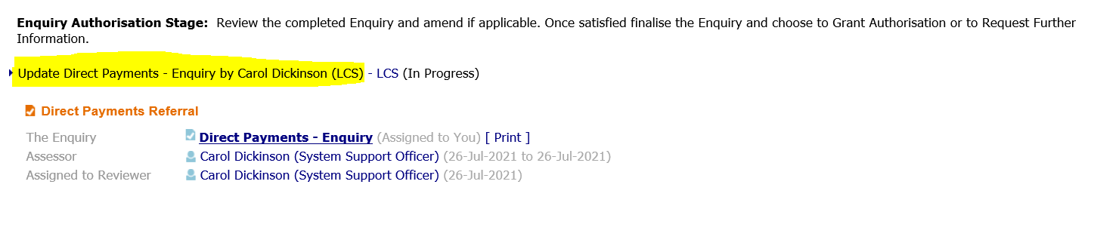
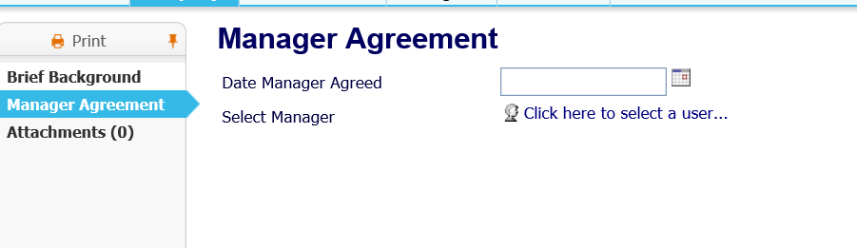
They will be, after finalising the form able to request further info or authorise
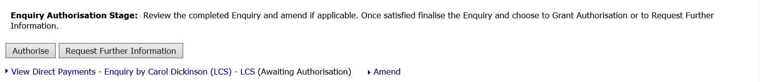
If the manager selects to authorise then a task will appear in the new Direct Payments Group tray

Panel form
The panel form will be completed in full by the admin support for the panel. The panel will discuss the request and the proposed outcomes and may agree it or may suggest that there are other ways for the outcome to be more effectively met or ask for further information. The aim of the panel is to ensure that the child’s outcomes are met in the best way possible, the social worker is provided with support to think about any other possible options which they may not be aware of and that there is a good understanding of the needs of children being assessed as requiring additional support.
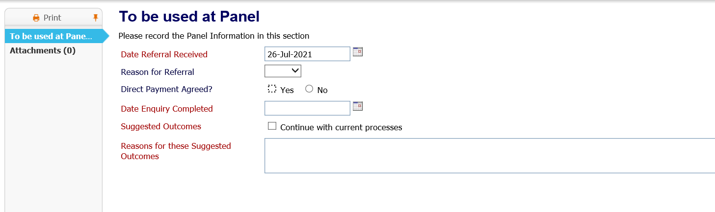
If the payment is agreed then a review date will be set.
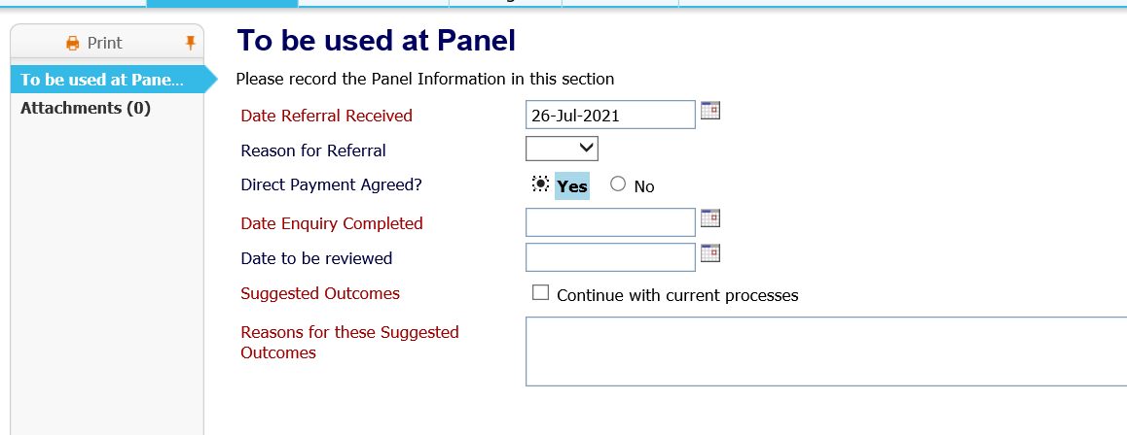
If the panel don’t agree with the payment and it is declined then a reason will be selected which will allow us to review any trends or patterns in this to identify knowledge gaps and further learning for workers. The alternative suggestions should be discussed with the parents/young person and if there is disagreement then a further date for discussion at panel can be sought by yourself by contacting Sandra Blackwood.
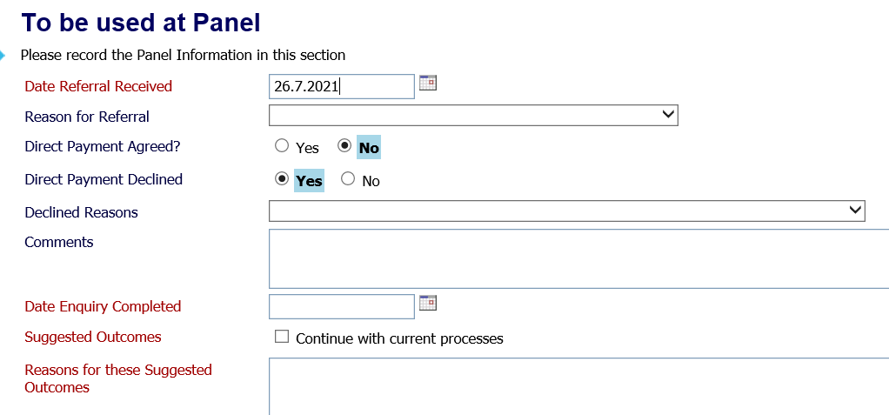

Panel Review
If the direct payment is agreed a review date will be set. This will most likely be linked to the child's next CIN review although if there are questions to be explored from the The admin support for the panel will complete the workflow process to set the date and time of the review meeting and they will assign the pre meeting report to the allocated worker to complete.
The allocated case worker will select to write pre meeting report and they can copy forward the previous forms. Whilst this may be useful to bring forward previous relevant information there should always be an updated view of what the payment will be for in the coming period and what outcomes it will look to achieve as these may change over time.
Even if there has been agreement that the direct payment will end at the review point the form should still be completed.
Once finalised this will go to your manager to approve.
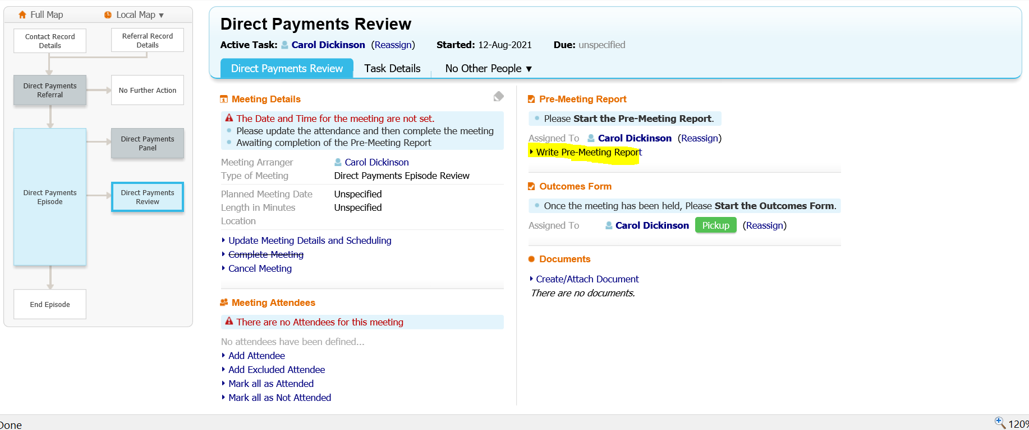
If the outcome of the panel review is to continue with the direct payment then the above review process will start again. If it is not agreed and another suggestion is made then this should be taken back to be discussed with the family and if necessary a further date set at panel to discuss if the parents/young person don’t agree with the suggestion.

To access the Direct Payment workflow at any point you can select Episodes on the Left of the demographics
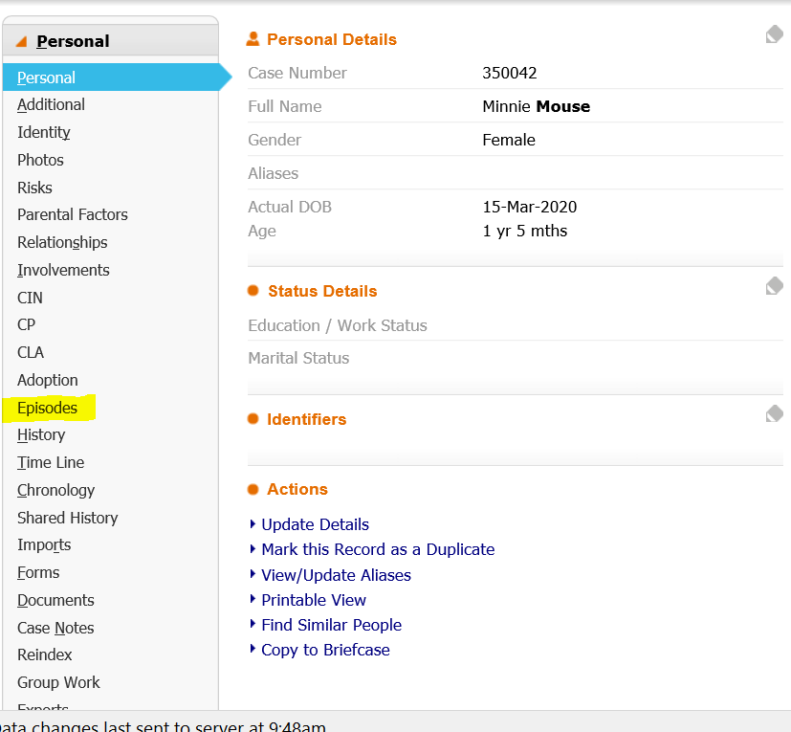
Then select the workspace – which will take you into the workflow
