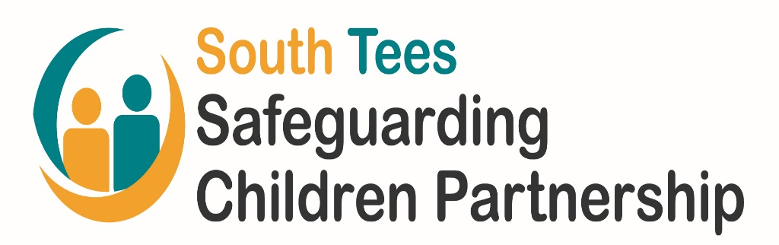

Redcar and Cleveland VEMT Practitioner Group

Weekly Process

September 2020 – Version 1

VEMT – Vulnerable, Exploited, Missing or Trafficked

Redcar and Cleveland are committed to keeping all our
children safe from exploitation.

VPG Weekly Meetings and Updates

The weekly VPG meetings are scheduled throughout the year and are usually held on a Monday morning.

See attached flow chart “VEMT Practitioner Group Weekly Flowchart” (see appendix 1).

Each week, new referrals, deferred cases, missing episodes for active VEMT cases and missing children meeting a set criteria are reviewed at the VPG meeting to determine exploitation concerns, identify any actions, and an outcome agreed.

New referrals

- Practitioner identifies concerns indicative of VEMT exploitation risk
- Practitioner to complete a SAFER referral and VEMT screening tool (see appendix 2) and to forward as indicated on the form.
- R&C MACH will review these documents and forward to: MissingChildren@redcar-cleveland.gov.uk
- For new referrals, an email is sent to the GP to request completion of VEMT GP Report Pro-forma (see appendix 3) which is to be completed and returned within 2 working days.
- Referrer may be invited by email to attend the weekly VPG meeting to present this information. Referrer must confirm their attendance, or if unable to attend, to send a representative to present the case on their behalf.
- A decision will be made to determine if the criteria for VEMT is met.

Deadline for acceptance of referrals to weekly VPG meeting is the Wednesday prior to VPG the following Monday.

Missing Children

- Children with missing episodes which meet the set criteria, are included in the weekly VPG agenda, alongside any missing episodes for active VEMT cases.
- Missing episodes and return home interviews are reviewed at the meeting to determine any links to exploitation.
- The involved professionals will be requested to provide a written update for the meeting.
- A decision will be made to determine if the criteria for VEMT is met.

Attendance
The referrer and allocated worker will be expected to attend the VPG meeting and to submit a written update.

Reports / Updates
VPG members will complete the relevant VEMT Case Review Information Sharing Pro-forma (see appendix 6) for any child listed on the agenda where their service is involved, or they have information to share and email to MissingChildren@redcar-cleveland.gov.uk. The deadline for submission is within 2 working days.

The allocated worker will complete the VEMT Case Update Pro-forma (see appendix 7) and email to: MissingChildren@redcar-cleveland.gov.uk. The deadline for submission is within 2 working days.

VPG Weekly Meetings – Decisions

VPG decisions are made on a multi-agency basis and there are three possible outcomes:

- Accepted
- Not accepted
- Deferred
Decision: Case not accepted (threshold not met)

Recommendations may be made by the VPG regarding appropriate interventions and actions may be identified for professionals.

Practitioner can re-refer at any time if the case escalates.

- Where a child is not accepted as a VEMT case, but the group identifies they may pose a serious sexual or violent risk, a referral to MAPPA will be considered.
- Where a child is not accepted as a VEMT case, but the group identifies they may be at risk of / is a victim of domestic abuse, a referral to MARAC will be considered.
- Where a child (aged 16 and over) is not accepted as a VEMT case, the group to consider a referral to the STAGES project, who support women and girls groomed by an individual or a group of people for sexual exploitation.
- Referrer/allocated worker will receive an outcome letter to advise of the VPG decision (which will detail any identified actions or recommendations made) within 2 working days of the VPG meeting (for referrals only). A copy of the letter is uploaded onto the child’s LCS/EHM record.
- VEMT case note is created within LCS which details the VPG decision, any identified actions and details of discussion. This case note is entered within 2 working days and notification sent to the allocated worker, their manager and the IRO (where involved). Case note is then finalised.
- Where the child is an active case to Early Help Services, a case note which details the VPG decision, any actions and details of discussion, will be added to the child’s EHM record within 2 working days.
- VEMT data case note is created and finalised within LCS (for reporting purposes) within 2 working days.
- For agencies who do not have access to LCS/EHM, an email detailing any actions will be sent within 2 working days of the VPG meeting.
- The minutes of the meeting will be completed and circulated within 4 working days.

Decision: Case deferred

Cases may be deferred for a number of reasons, such as; absence of information or referrer not in attendance (therefore unable to provide supplementary information).

- Referrer/allocated worker will receive an outcome letter to advise of the VPG decision within 2 working days of the VPG meeting (for referrals only). A copy of the letter is uploaded onto the child’s LCS/EHM record.
- VEMT case note is created within LCS which details the VPG decision, any identified actions and details of discussion. This case note is entered within 2 working days and notification sent to the allocated worker, their manager and the IRO (where involved). Case note is then finalised.
- Where the child is an active case to Early Help Services, a case note which details the VPG decision, any actions and details of discussion, will be added to the child’s EHM record within 2 working days.
- VEMT data case note is created and finalised within LCS (for reporting purposes) within 2 working days.
- For agencies who do not have access to LCS, an email detailing any actions will be sent within 2 working days of the VPG meeting. Case note is then finalised.
- The minutes of the meeting will be completed and circulated within 4 working days.
- Child’s name added to the relevant future VPG agenda for further discussion.
Decision: Case accepted

When the VEMT criteria is met and the child is accepted as a VEMT case, a category and level of risk is determined (see appendix 4)

- Actions and intervention required identified within the VPG meeting.
- Where the group identifies a child who poses a serious sexual or violent risk, a referral to MAPPA will be considered.
- Where the group identifies a child who may be at risk of / who is a victim of domestic abuse, a referral to MARAC will be considered.
- Where the group identifies a female child (aged 16 and over) who has been groomed by an individual or a group of people for sexual exploitation, a referral to the STAGES project to be considered.
- Where the group identifies a child who may be a victim of trafficking, the completion of a NRM will be considered. Where a positive conclusive grounds decision is given, the VEMT trafficking hazard marker will be added to the child’s LCS record.
- Lead Professional is identified, who will deliver the VEMT letter and leaflet to parents/carers and child (see appendix 5).
- Lead professional tasked to list any known peers, places and perpetrators.
- Referrer/allocated worker will receive an outcome letter to advise of the VPG decision within 2 working days of the VPG meeting. A copy of the letter is uploaded onto the child’s LCS/EHM record.
- VEMT hazard is added to child’s LCS record within 1 working day.
- VEMT case note is created within LCS which details the VPG decision, any identified actions and details of discussion. This case note is entered within 2 working days and notification sent to the allocated worker, their manager and the IRO (where involved). Case note is then finalised.
- Where the child is an active case to Early Help Services, a case note which details the VPG decision, any actions and details of discussion will be added to the child’s EHM record within 2 working days.
- For agencies who do not have access to LCS/EHM, an email detailing any actions will be sent within 2 working days of the VPG meeting
- Notification sent to GP to advise child is an active VEMT case within 2 working days of the VPG meeting.
- Email information exchange group established by the VEMT team and shared within 4 working days. Any intelligence received on a child should be circulated utilising the email information exchange group set up for each child.
- The minutes of the meeting will be completed and circulated within 4 working days.
- VEMT case profile created and uploaded to the child’s LCS/EHM record within 3 weeks of the weekly VPG meeting and will include details of discussion from the VPG meeting. Notification of the VEMT case profile sent to the allocated worker, their manager and the IRO (where involved).
- The case map for each child is created and added to the VPG Case Profile within 3 weeks of the weekly VPG meeting.

Cases are then reviewed at the monthly VPG meeting until the exploitation risk is reduced.

Produced by: | Jayne Hunt, VEMT Coordinator
Date: | September 2020
Version: | 1

Appendices

Appendix 1 - VEMT Practitioner Group Weekly Flowchart

Appendix 2 – VEMT Referral Forms – SAFER Referral and VEMT Screening Tool

Appendix 3 – VEMT GP Report Pro-Forma

Appendix 4 – VEMT Categories and Risk Levels

Appendix 5 – “VEMT Practitioner’s Guide for parents and/or carers” / Guide to Child Criminal Exploitation (CCE) for parents and/or carers”

Appendix 6 – VEMT Case Review Information Sharing Pro-Formas

Appendix 7 – VEMT Case Update Pro-Forma

