BCP Childrens Services Feedback Form
Have Your Say ……

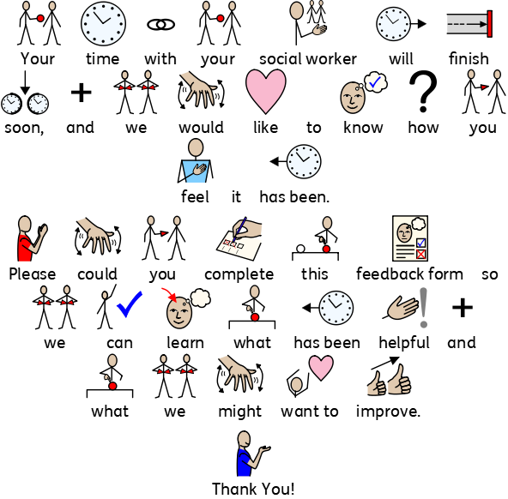

0
1
2
3
4
5
6
7
8
9
10
Scale: 0 (Not at all) – 10 (Social worker said why they were visiting)

Comments:

0
1
2
3
4
5
6
7
8
9
10
Scale: 0 (Not at all) – 10 (social worker did listen to me)

Comment:

0
1
2
3
4
5
6
7
8
9
10
Scale: 0 (not at all) – 10 (very much)

Comment:

0
1
2
3
4
5
6
7
8
9
10
Scale: 0 (not at all) – 10 (very much)

Comment:

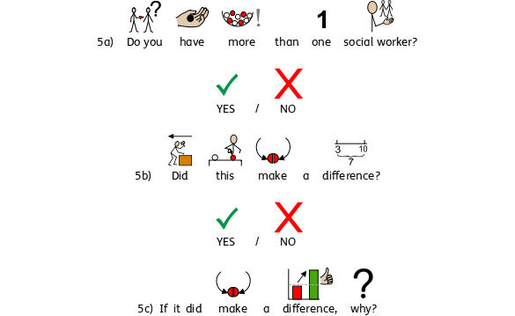
It made a difference because…

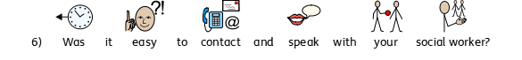
0
1
2
3
4
5
6
7
8
9
10
Scale: 0 (not at all) - 10 (It was very easy)

