Title: | Parents with learning difficulties
Prepared by: | Khadija Tai |  | 22.03.2021
Intended audience: | Internal ☒

Purpose

The purpose of this briefing is to share developments from the working group on parents with learning difficulties and outline proposed processes and next steps.

A note about terms

- Learning difficulties refer to a range of difference in a person’s cognitive (thinking) skills which affect their ability to understand, process or retain information. They can be specific (e.g. literacy, language, mathematical) or general, and range from mild (affecting 10-20% of the population) to severe (affecting 1-2% of the population)
- Learning disability is a diagnostic term used to define general learning difficulties at a level. For a diagnosis of a learning disability a person will meet the following criteria:
  - Severe impairment of cognitive functioning – i.e. an IQ score below 70 (bottom 2%); and
  - Impaired social functioning (ability to cope with everyday skills and tasks)
- IQ refers to intelligence quotient and is a score that is used to estimate a person’s cognitive skills in comparison to the general population. The average score is 100. IQ tests usually measure verbal and non-verbal reasoning skills, and some measure short-term memory and spatial or other processing skills.
- Most people with learning difficulties experience difficulties from childhood, but some can acquire difficulties due to acquired brain injury, the result of drink or drug use, or as part of a neurodegenerative condition.

Background and context

From August 2020- Feb 2021, a small working group was convened to identify ways of improving approaches to identifying and supporting parents with learning disabilities. The group comprised Julie Link, Principal Educational Psychologist, Khadija Tai, Service Manager and Nisha Gupta PSW.

Current practice in relation to parents with learning difficulties in Sandwell in order to identify learning disabilities a social worker might seek a cognitive assessment of the parent, either through a referral to Resource Panel to commission an independent assessment. They may also request a PAMS (Parent Assessment Manual) assessment. There are various problems with the current situation in some cases:
- Assessments are often requested late in the planning process – it helps to explain why intervention has not been successful, rather than guiding how it could be successful.
- Commissioning independent assessments is costly.

The more fundamental issue, however, is that a cognitive assessment is an inappropriate tool for identifying parenting skills or the capacity of a parent to change or engage with support. A cognitive assessment cannot identify what a parent’s support needs are.

In respect of parents with learning difficulties, research evidence suggests:
- The link between assessed cognitive ability and parenting skills is tenuous – only for those with a very low IQ (i.e. <60) does there appear to be any relationship.
- Parents with learning difficulties are more likely than others to have children removed.
- Parents with learning difficulties can be taught to develop effective parenting skills, but this requires differentiation and individually-tailored support. Effective strategies to help parents with learning difficulties to develop new skills can include, e.g. simplifying language, use of checklists, direct instruction, visual support, breaking tasks into small steps, teaching skills in context, increased rehearsal, interleaved learning.
- Parents with learning difficulties experience discrimination and exclusion though inaccessible child protection processes.

It is also important to note that if a parent does have a learning disability they are likely to be a vulnerable adult and may be eligible for an assessment of their needs under the Care Act.

Proposals

The view of the working group is that cognitive assessments are seldom, if ever, a useful tool for supporting parents who may have learning difficulties and improving outcomes for their children. The Educational Psychology Service have developed a screening tool (appendix 1) that can be used by front-line workers to identify if a parent has learning needs and to start discussions about the support needs.

Where a parent has learning difficulties, it is crucial that the parent’s vulnerabilities and support needs are identified, as well as the impact of any difficulties on the child. A whole family approach is necessary.

Being able to evidence what needs have been identified and how this has informed planning is crucial for effective planning in relation to legal processes.

The following is an outline process for identifying and working with parents with learning difficulties.

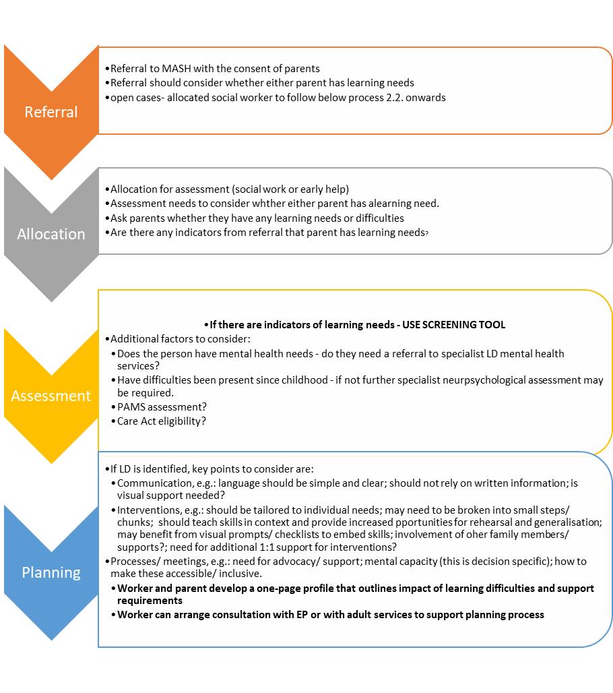
Email referral to inclusion_support@sandwell.gov.uk - in the title line mark REFERRALS FAO: JULIE LINK

NEXT STEPS
Action | By when
- Process to be shared with HOS Allison | 26th March 2021
- Briefing note to be shared with Care management colleagues | Early April 2021
- Educational Psychologist to provide 1-1 session from April 2021 – 1 slot | 20th April 2021
- Formal practice guidance on working with parents with learning disabilities agreed by children’s and adults’ management teams | April 2021
- Identification of Champions for hidden disabilities (LD and autism) across children’s services | April 2021

