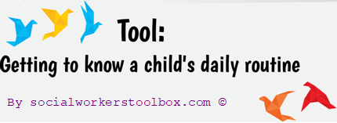

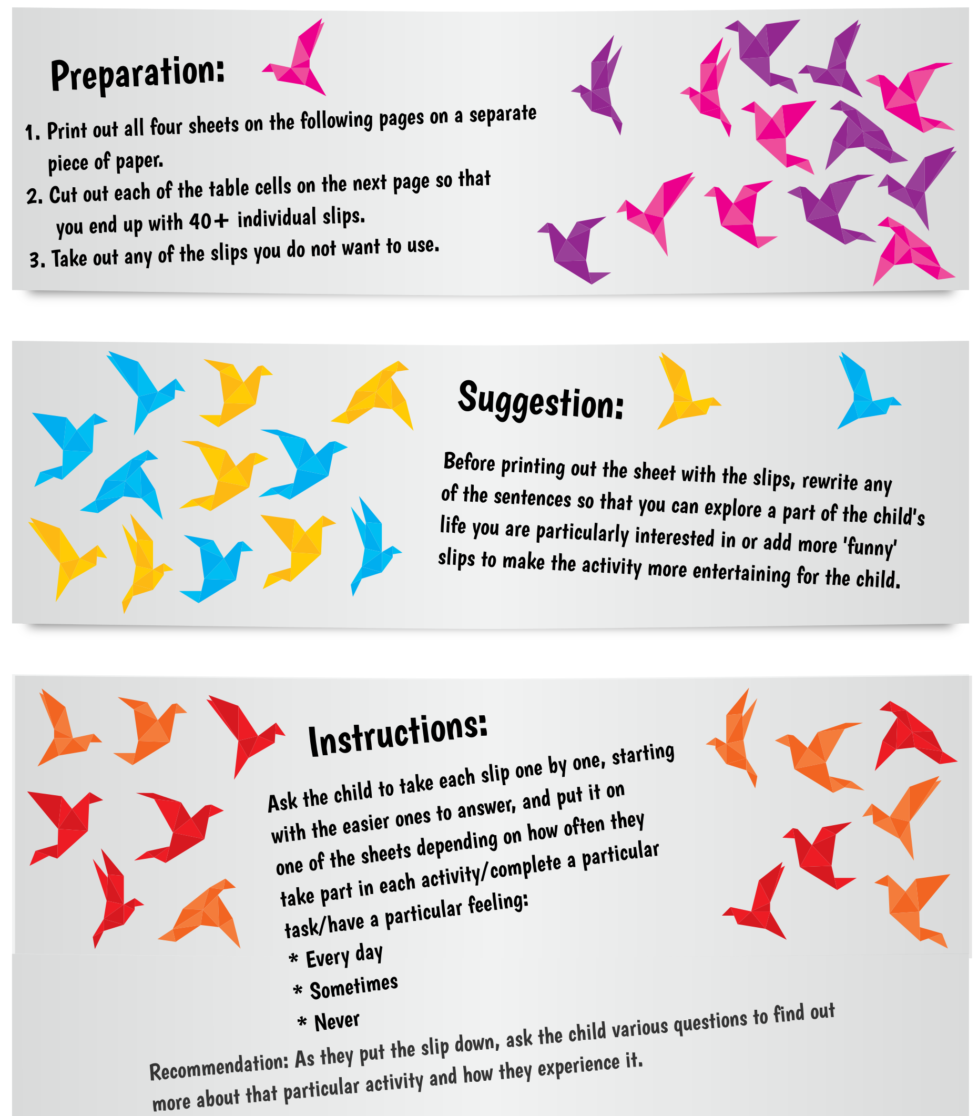

Brush my teeth | Get into a fight
Go to school | See a friend
Have breakfast | Get a hug
Have lunch | Get a kiss
Have dinner | Laugh
Watch TV | Cry
Have fruit or vegetables | Get shouted at
Eat something nice | Get bullied
Get pocket money | Feel happy
Stay at home alone | Feel sad
Do household chores | Feel scared
Play inside | Get angry
Play outside | Get praised
Read | Put my hands over my ears
Do sports | Ride a cow
Sing | Dress up as a gorilla
Dance | Eat chocolate with ketchup
Take medicine | Stroke a spider
Have fun | Wear all my clothes at once
Do something silly | Smell my feet
Do homework | Have a piggy back ride
Hide | Do a handstand
Play with toys | Feel special
Have a wash | Get bored

EVERY DAY

SOMETIMES

NEVER

